

Faculty of Science, Engineering and Technology

Computer Systems
Week 5

Overview
In this laboratory session we start look at memory, encoders and stacks. Purpose: To consolidate your knowledge of Memory and Stacks
Task:
Time: This lab is due by the start of your week 6 lab.
Assessment: This lab is worth 1% (up to a maximum of 5%) of your assessment for this unit, and only if demonstrated to your lab demonstrator in the week it is due.
Resources: ■ This week's lecture videos
Submission Details
You must submit the following files to Canvas:
■ A document containing all required work as described below.

Computer Systems Week 5 Laboratory

Instructions
Theory (Memory, Architectures, Interrupts and Stacks)
- Review the lecture slides on types of memory and provide a short answers to the following questions (using your own words):
  - What is ROM and what is its primary purpose ?
Answer: ROM (Read-Only Memory) is a type of memory that stores data permanently, even when the computer is turned off. It is commonly used to store important system information like the BIOS, or in cases where data needs to stay unchanged for a long time.

  - What is RAM and how is it different from ROM ?
Answer: RAM (Random Access Memory) temporarily stores data that the computer is currently using and is cleared when the power is turned off. Unlike RAM, ROM is non-volatile and keeps its data permanently. Programs stored in ROM must be copied into RAM before they can be used, which makes RAM faster to access.

  - What is the difference between static RAM and dynamics RAM ?
Answer: -SRAM requires a constant power supply, so it consumes more power than DRAM.
-DRAM uses capacitors to store data, which allows it to use less power. However, SRAM has a much faster access time, making it faster than DRAM overall.

  - What type of memory is typically used in USB thumb drives ? Why shouldn’t we rely on this for critical data storage ?
Answer: USB thumb drives use flash memory to store data. However, this type of storage has limited capacity and slower read and write speeds compared to modern storage devices. Because of this, USB drives are not suitable for storing critical or important data.

- Consider a computer with 1GB RAM (1024 MB). Given memory addressing is for each byte, how many bits are needed to address all bytes in the system’s RAM ?
Answer: 1 GB of RAM is equal to 1024 MB, which is 2^30 bytes. Since each byte needs a unique address, the system must be able to represent 2^30 different addresses. Therefore, 30 bits are required to address all bytes in the RAM.

- Give a brief description of the Von Neumann and Harvard computing architectures. What are the fundamental differences between the two and for what is is each designed to achieve ?
Answer:
-Von Neumann architecture is based on the stored-program concept, where both instructions and data are stored in the same memory and use a single bus for transfer.
-Harvard architecture stores instructions and data in separate memories and transfers them using different buses.
-Main difference: Von Neumann uses shared memory and a single bus for both data and instructions, while Harvard separates both memory and buses.
-Usage: Von Neumann architecture is commonly used in general-purpose and personal computers, whereas Harvard architecture is mainly used in microcontrollers and digital signal processing systems.

- What is cache memory and what is its primary role ?
Answer: Cache memory is a small, high-speed memory that temporarily stores frequently used data and instructions. It helps the CPU access information faster, improving overall system performance.

- Explain the concept of an interrupt, and list four common types.
Answer: An interrupt happens when the CPU is executing a task and is temporarily stopped to handle another request.
Common types of interrupts include:
-Clock interrupt
-Hardware interrupt
-Network interrupt
-Exception interrupt
  - Polling is an alternative to interrupts? Briefly explain polling and why it is not commonly used.
Answer: Polling is a method where the CPU repeatedly checks each device to see if it needs attention. It is not commonly used because it wastes CPU time and is inefficient compared to interrupt-based methods.

- Explain the general concept of a stack - how do they work, and what is their primary purpose.
Answer: A stack is a linear data structure that stores data in an ordered way. It follows the Last In, First Out (LIFO) principle, meaning the most recently added element is the first one to be removed. Stacks provide a simple and efficient way to store and retrieve data.

  - How are stacks useful for handling interrupts?
Answer: An interrupt handler is a hardware-triggered function that can be nested, meaning multiple interrupts may occur before the previous one finishes. Because of this, a stack is needed to store return addresses correctly.

  - How are stacks useful in programming?
Answer: Stacks are commonly used to implement function calls, parsers, expression evaluation, and backtracking algorithms.
Provide all the answers to the above questions in your submission document.
Practical - Stacks of Stacks !
- Start Logisim and open a new canvas
- Review the lecture slides on building a stack at the top of this lab sheet. We are going to build a 5-bit deep, 1-bit wide stack.
- Start by building a simple shift register that moves bits from one flip flop to the next each clock pulse. For this you will need a “Data In” pin which sets the next bit to be pushed to the stack, and a clock to invoke the shifting.
- For your shift register to work as a stack, it needs to be bi-directional. This means the input to any Flip Flop could come from two places - the left or the right. In lectures we discussed a simple “encoder” circuit that selects which of two data inputs is allowed through, based on a third selection bit. Design the logic for this 2-bit encoder, and demonstrate it to your lab demonstrator.
Computer Systems Week 5 Laboratory
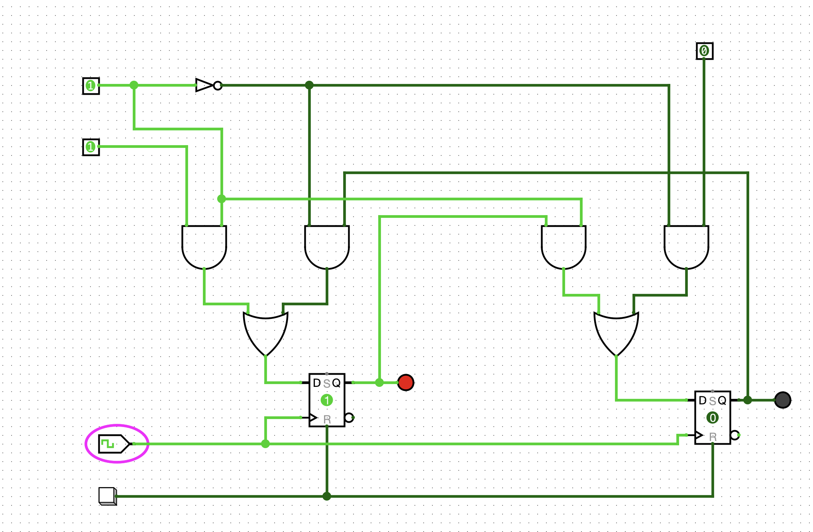

- Now incorporate your encoder above to allow bi-directional shifting of your stack. Your stack should:
  - push and pop bits onto and off the stack, using clock pulses and a direction toggle switch
  - show the state of each Flip Flop using LEDs.
Export your circuit as an image and include it in your submission document. Demonstrate your working stack to your lab demonstrator.
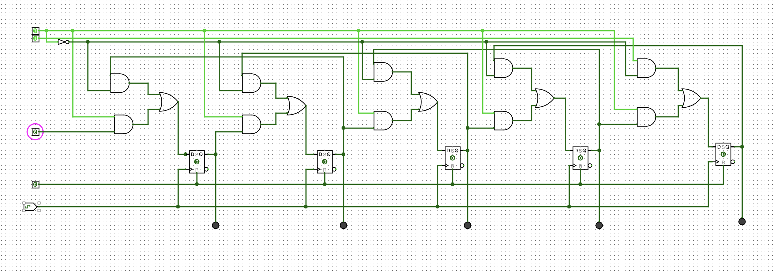
- Modify your stack so that it has the option to read out its contents in parallel to a separate register of D Flip Flops. This should only occur when a “stack dump” toggle switch (i.e., pin) is enabled. When the toggle is disabled, the register of D Flip Flops should retain the last state read in (and should have LEDs connected to each Flip Flop out showing its state).
Export your circuit as an image and include it in your submission document. Demonstrate your working stack to your lab demonstrator. 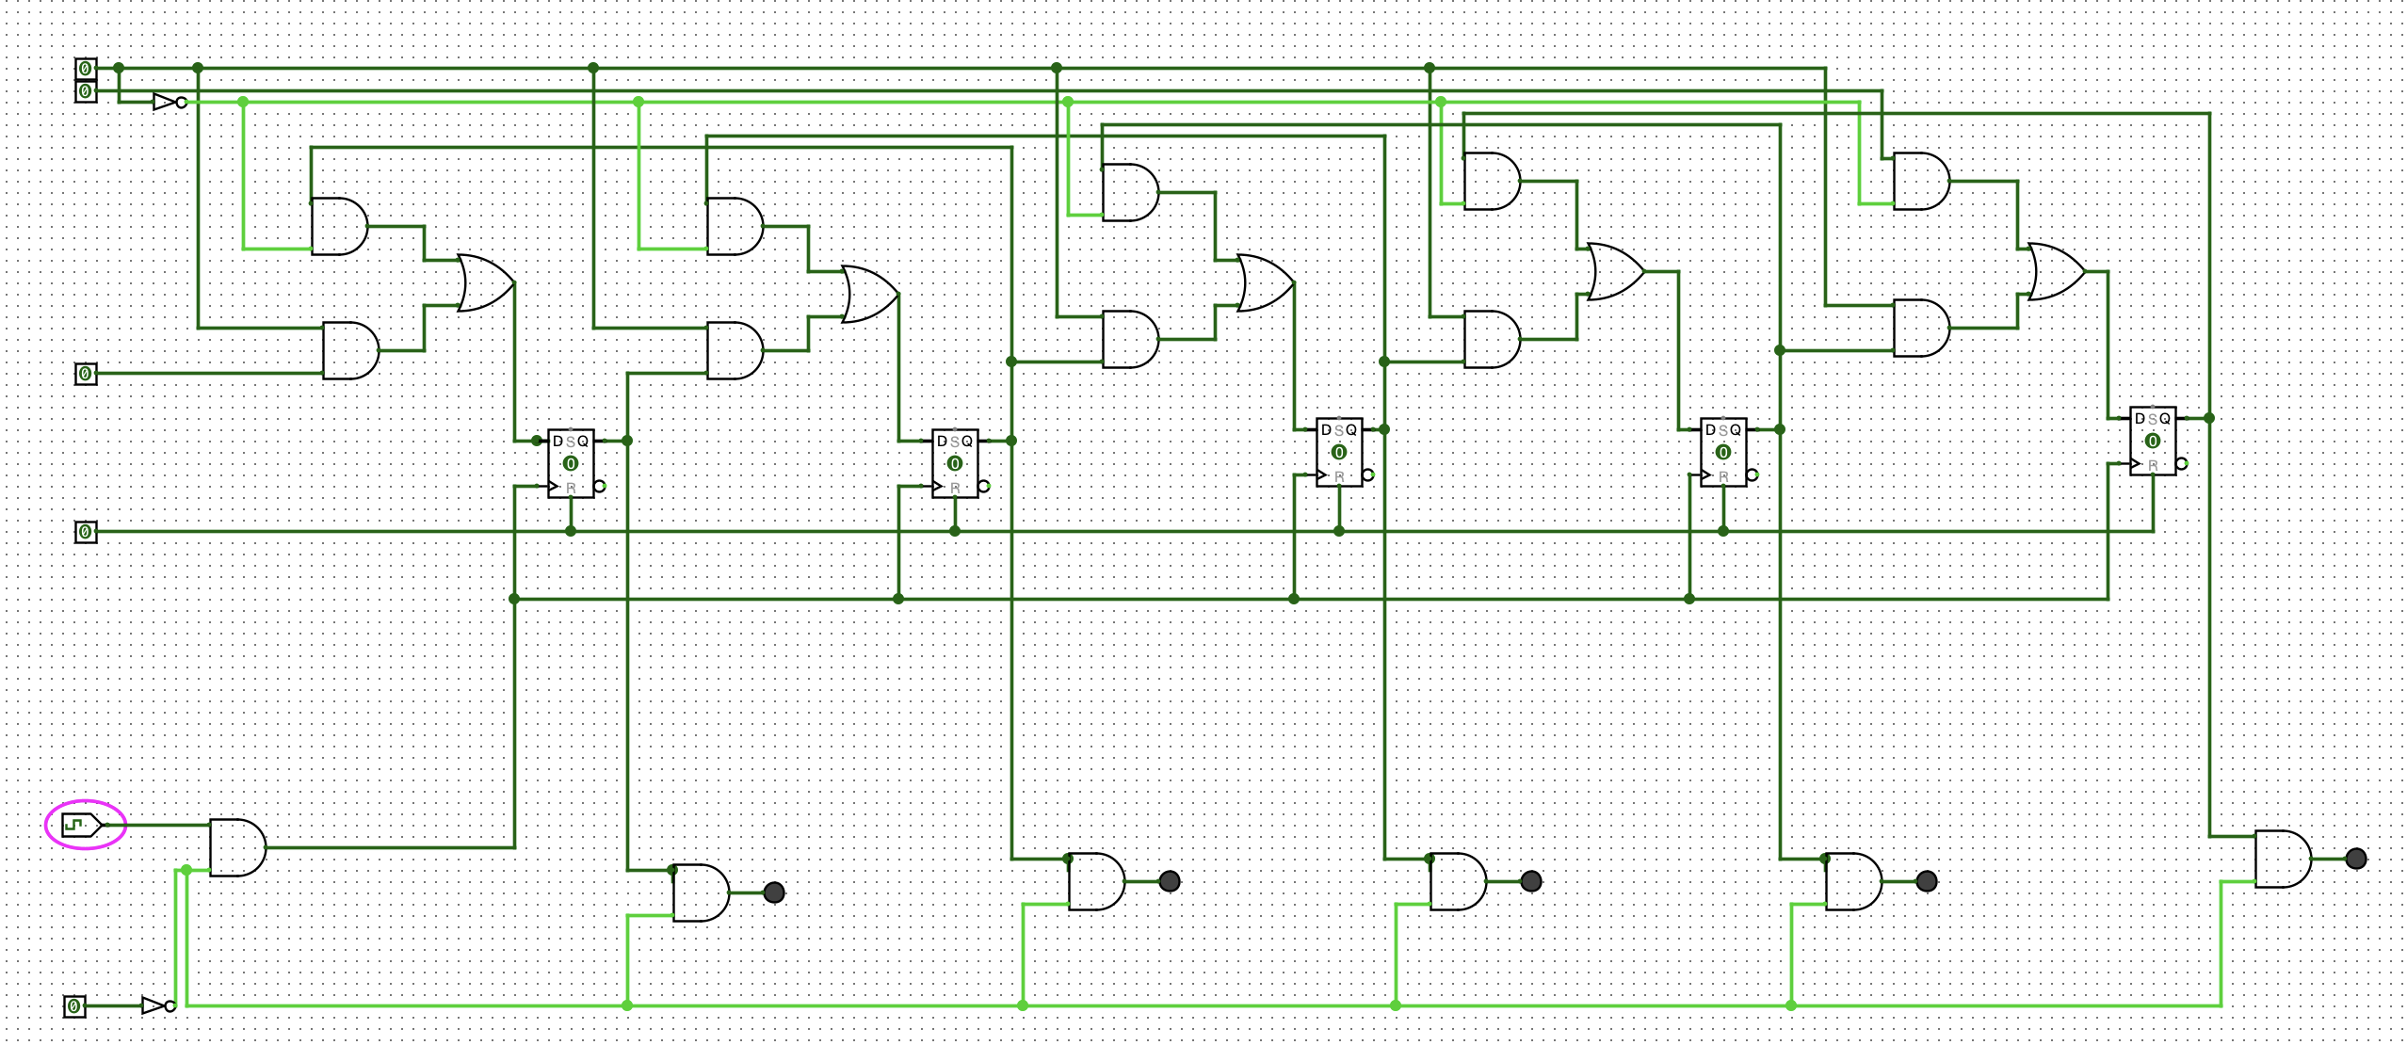
When complete:
■ Submit your answers (screen shots, etc) in a single document using Canvas
■ Show your lab demonstrator your working circuits in class (you must do this to get the 1%). Your lab demonstrator may request you to resubmit if issues exist.
Page 3 of 3

